Pinpoint: Helga Zumstein at Agora Gallery

SPONSORED CONTENT BY BLOUIN GALLERY GUIDE

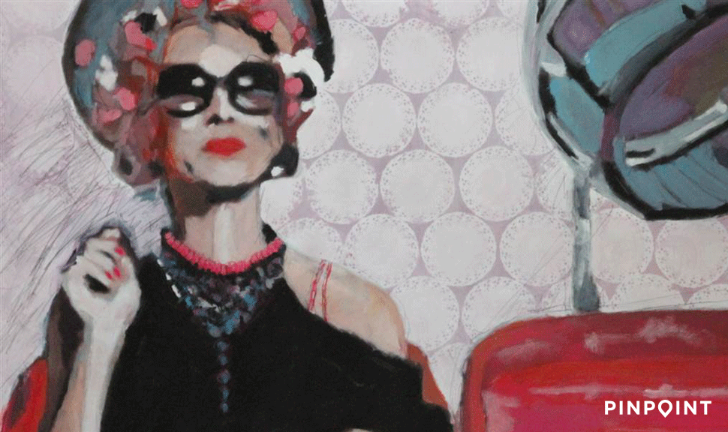

(Courtesy of Agora Gallery )
- EVENTS Helga Zumstein: The Art of Intimacy
- VENUES Agora Gallery

Looking between the bodies and interactions in Helga Zumstein's work, any viewer can rejoice in her coded messages. Her wholly recognizable scenes show with graphic aptitude that art is everywhere, but sometimes it takes an artist to truly capture it. Zumstein, a Swiss national, has made painting her mission and her passion, and she incorporates into her works her experiences and appreciation for artistic institutions such as museums, galleries, and art schools.
With great care and a long exposure to the fine arts, she has developed a stoic perspective on the often vague delineations of what art is. For Zumstein, art is the space beyond the frame as well as the space inside it. In her words, her paintings are meant to "extract the special out of the ordinary; the precious out of the banal." Her gaze focuses on domestic and bucolic scenes, but also highlights and celebrates the artistry of the quotidian life; how in every day and every interaction we turn ourselves and our environment into monuments of self-expression.
smart_paging_autop_filtersmart_paging_filter
Although primarily working with traditional media, Zumstein has welcomed various technological developments into her process as a means of playing with realism. The Swiss artist has described her camera as her primary source of inspiration and her "permanent companion," and her work easily draws comparison with the compositional elements of photography. Zumstein, however, strays into the poetic side of realism, using a minimal acrylic palette and taking liberal diversions from her sources of inspiration. Her techniques have allowed her to achieve a refined sense of irony while simultaneously instilling in her paintings a certain quiet dignity. As her focus remains fixed on the living characters that inhabit her paintings, she preserves a striking sense of intimacy that permeates her work.
At the forefront of Zumstein's paintings is a sense of spontaneity, movement, and moment, both personal and universal, captured almost as if by chance. It's in this deeply personal manner that she treads the line between self-expression and hints at the inexpressible and the universal. The moments depicted in Zumstein's paintings are moments that could happen to anyone, and the beauty that Zumstein holds up is the type of beauty that goes unnoticed in one's hectic day-to-day life. Rather than treating her figures like still lifes, Zumstein imbues them with a contemplative nature, producing a mirror not just for the artist, but for anyone willing to observe their reflection and smile back.
Helga Zumstein will be showing her artwork at Agora Gallery this July, 2015 with an opening reception on July 9th, 2015.

